A Data-Driven Analysis of Salary Trends in Big Data and Computer Science

Smit Thakore
Computer Science Engineering(SOT)
Pandit Deendayal Energy University
Gandhinagar,India
smit.tce@21sot.pdpu.ac.in

Stuti Desai
Computer Science Engineering(SOT)
Pandit Deendayal Energy University
Gandhinagar,India
stuti.dce@21sot.pdpu.ac.in

Abstract—Data science is a rapidly growing field with increasing demand for skilled professionals. Analyzing and predicting data science salaries is crucial for individuals considering a career in this domain, as well as for companies seeking to attract and retain top talent. This review paper delves into the specific use of statistical and ML techniques for analyzing and predicting data science salaries, with the help of regression models. We seek to uncover insights into the factors that influence income levels, such as type of employment, level of experience, ratio of remote job, company location along with residence of employee. The analysis is performed on a dataset of over 13,000 records. The findings of this study can help inform career decisions for aspiring computer science students and provide guidance for educational institutions and policymakers.
Keywords: Exploratory Data Analytics, Regression, Computer Science

Introduction
In the rapidly evolving landscape of computer science, big data has emerged as a pivotal domain driving innovation, insights, and value across industries. The pervasiveness of data science and its affiliated disciplines, Artificial Intelligence (AI) and Machine Learning (ML), is undeniable. From deciphering complex medical records in healthcare, optimizing traffic flow, analyzing structural integrity in civil engineering, and even predicting crop yields in agriculture, data science has permeated nearly every domain. In healthcare, AI-powered diagnostics and personalized treatment plans are transforming patient care. Civil engineers leverage real-time traffic data to design smarter infrastructure, while agricultural scientists utilize ML models to optimize crop production and resource management. These are mere examples; the reach of data science extends far and wide. As organizations increasingly recognize the transformative potential of data-driven decision-making, the demand for skilled professionals in big data roles has surged, leading to significant shifts in salary trends and market dynamics.
This review paper delves specifically into data science salary trends over a period of four years (2020-2024) using a data-driven approach. We leverage the power of Microsoft Power BI, a robust business intelligence platform, to visualize and explore salary data from various sources. Power BI's intuitive interface allows us to create interactive dashboards and reports, facilitating a comprehensive understanding of salary trends across different data science roles, experience levels, and geographic locations. Furthermore, Exploratory Data Analysis (EDA) techniques will be employed to uncover hidden patterns and relationships within the salary dataset. EDA involves techniques like calculating descriptive statistics, identifying outliers, and visualizing data distributions. By implementing these methods, we can gain deeper insights into factors influencing data science salaries, such as specialization, type of employment, level of experience, ratio of remote job, company location along with residence of employee. This combined approach, utilizing Power BI for visualization and EDA for in-depth analysis, will illuminate the evolving landscape of data science compensation.
we also incorporate the expertise of regression models since data contains numerical values, regression models provide an ideal solution. These models learn the underlying relationships between various factors, such as experience level, skillset, and location, and the corresponding salary. Through the training process, regression models establish an equation that can be used to predict salaries for new data points. For this specific task of predicting data science salaries, we will focus on four powerful regression models: Decision Tree, Random Forest, Gradient Boosting, and XGBoost. To assess the performance of these regression models, we will utilize the R-squared loss metric. R-squared, ranging from 0 to 1, represents the proportion of variance in the target variable (salary) explained by the model's predictions. A higher R-squared value indicates a better fit between the model and the data. Categorical variables like job title or industry within our regression models are pre-processed using common techniques like encoding which transforms categorical data into numerical representations that the models can understand.
This review paper offers a multi-faceted exploration of data science salary trends over the past four years (2020-2024), aiming to provide valuable insights for both employers and data science professionals. Our contributions encompass the following:
1. Power BI and EDA for Interactive Visualization: We create insightful dashboards and reports to visualize salary trends across different roles, experience levels, and locations. And uncover hidden patterns and relationships within the dataset, providing deeper understanding of factors influencing salary of individuals.
2. Regression Algorithms for Predictions: We incorporate Random Forest, Gradient Boosting, XGBoost, and Decision Tree regression models to predict future salary trends based on various influencing factors.
The insights gleaned from this analysis can provide valuable guidance for navigating the complex landscape of salary trends and changing shape of salary structures in these computer science roles

METHODOLGY

!. Data Collection
For this review paper, data was collected from https://ai-jobs.net. This dataset is published in the public domain and legal use is performed. Salary information was collected anonymously from professionals and employers all over the world and make it publicly available for anyone to use, share and play around with. Publisher’s goal is to have open salary data for everyone. So newbies, experienced pros, hiring managers, recruiters and also startup founders or people wanting to switch careers can make better decisions.
The dataset comprises a total of 15,582 data points, with its associated salary details that is 11 fields of salary information. Work year, four levels of experience, four type of employment such as part-time, full-time, more than 150 unique job titles, reported salary along with its currency, company size and location, employee residence and finally remote ratio of work such as fully work from home, hybrid or no remote work. The compiled dataset served as the foundation for the subsequent analysis and exploration of salary trends in big data roles.

Table head | Table Columns
Table head | Field | Unique | Top | Frequency
1 | job title | 155 | Data Enginee | 3276
2 | employee residence | 88 | United States | 13599
3 | company location | 77 | United States | 13649
4 | experience level | 4 | Senior Level | 10135
5 | employment type | 4 | Full Time | 15510
6 | remote ratio | 3 | Non Remote Work | 10404
7 | company size | 3 | Medium | 14385
Table 1: Data description

2. Data Processing
Before initiating the analysis, the dataset underwent a comprehensive preprocessing phase to ensure its quality and readiness for analysis. This phase involved handling missing values, encoding categorical variables, and performing feature selection to streamline the dataset for the subsequent analysis.
Label Enconding for ordinal features, applied for company size, but not limited to only this column, replacing as given 'Small':1 ,'Medium': 2, 'Large': 3.One - Hot Encoding for nominal features and custom handling un-balanced job titles by merging similar job titles into one.
After all the data preprocessing we get around 13000 data points for six job roles.

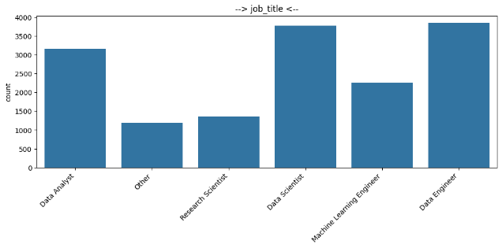
Fig 1: Distribution between job roles. Other include every other miscellaneous role apart from other five, such as Business Intelligence roles, Cloud engineer, Robotics, etc.

3. Exploratory Data Analysis
Using Microsoft Power BI’s dashboard we incorporated various visualizations, including charts, graphs, and tables, to provide a comprehensive overview of the data and its underlying patterns. The exploratory data analysis (EDA) phase, implied using python, was pivotal in unveiling preliminary insights, corelation between fields and identifying potential trends and patterns within the dataset.

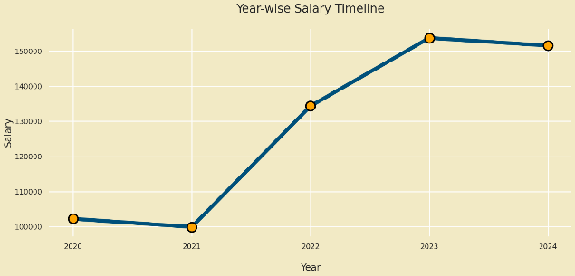
Fig 4: timeline of average salary over the years.

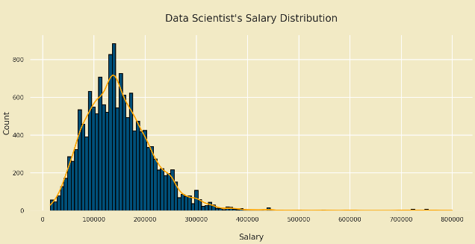
Fig 3: distribution of salaries over the years.
Very few earns more than average data scientist's earning but maximum data scientist's salaries fall in between 50000 to 200000.

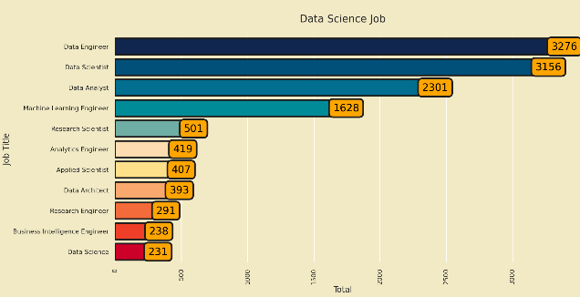
Fig 4: Top familiar data science jobs.
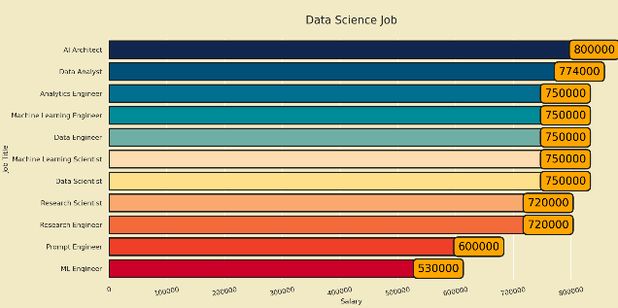
Fig 5: Top highest paid data science jobs.

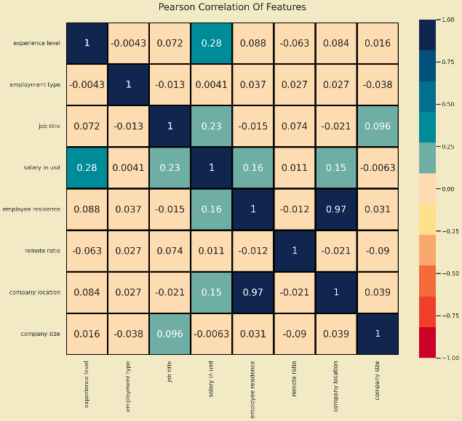
Fig 6: Correlation between fields. High correlation between employee residence and company location. Medium correlation between salary in usd and experience level, salary in usd and company location, salary in usd and employee residence.

4. Model Evaluation
Four machine learning algorithms were implemented to predict salary:

1. RandomForest: A collection of decision trees where each tree votes for the most popular class. RandomForest is known for handling large datasets with high dimensionality and provides feature importance scores.

2. GradientBoosting: This method builds an ensemble of decision trees sequentially, where each tree corrects the errors of the previous one. It is particularly effective in capturing complex non-linear relationships.

3. XGBoost: Extreme Gradient Boosting is an optimized implementation of GradientBoosting that uses regularization to prevent overfitting and parallel processing to improve speed.

4. Decision Tree: A single tree model that splits the dataset based on feature values to predict the target variable. It provides a clear visualization of the decision-making process but can overfit to the training data.

5. Evaluation
The coefficient of determination, denoted R² or r² and pronounced "R squared", is the proportion of the variation in the dependent variable that is predictable from the independent variable(s). In regression, the R² coefficient of determination is a statistical measure of how well the regression predictions approximate the real data points. An R² of 1 indicates that the regression predictions perfectly fit the data.

Dataset has n values marked y₁, ..., y_{n} (collectively known as y_{i} or as a vector y = [y₁, ..., y_{n}]^{T}), each associated with a fitted (or modeled, or predicted) value f₁, ..., f_{n} (known as f_{i}, or sometimes ŷ_{i}, as a vector f).
Define the residuals as e_{i} = y_{i} − f_{i} (forming a vector e).
If is the mean of the observed data:
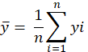
then the variability of the data set can be measured with two sums of squares formulas:
The sum of squares of residuals, also called the residual sum of squares:
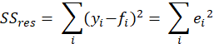
The total sum of squares (proportional to the variance of the data):
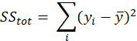
Hence, R squared loss is,
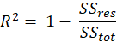

RESULTS AND DISCUSSION
We employed four prominent models: Random Forest, Gradient Boosting, XGBoost, and Decision Tree. Additionally, we explored the potential benefits of an ensemble approach by combining the predictions from these individual models. We have observed that Gradient Boosting Regressor have emerged as the best performing model throughout different training parameters.
The R-squared values obtained for each model were as follows:

Table head | Table Columns
Table head | Model | R-Squared values
1 | DecisionTreeRegressor | 0.5191
2 | XG-Boost | 0.5213
3 | Random-Forest Regressor | 0.5221
4 | Gradient Boosting | 0.5222
5 | Ensemble – All Stacked | 0.5219
Table 2: Results of ML models. Highest score is highlighted in Bold.

These results indicate that all four models performed relatively similarly, with Gradient Boosting Regressor slightly outperforming the others by a marginal difference. The dataset underwent comprehensive preprocessing, where feature engineering techniques were applied to manage missing values, encode categorical variables, and select relevant features for modeling. The unexpected achieved values are relatively low. This can be attributed to imbalances and biases within the dataset. For instance, the data leans heavily towards a Senior Level experience level (65% of total), Fully Remote job type (66% of total), and Medium company size category (92% of total), due to this models struggle to generalize and accurately predict salaries for less-represented categories.
The results and insights obtained from the analysis were discussed in detail, highlighting the significance of education level, occupation, and industry as strong predictors of income for computer science graduates. The conclusions drawn from the study were further validated and supported by the visualizations and graphs presented in the Power BI dashboard, reinforcing the robustness and reliability of the findings.
In summary, the methodology employed in this research encompassed data collection and preparation, dashboard creation using Power BI for interactive visualization, exploratory data analysis to uncover preliminary insights, application of machine learning algorithms for predictive analysis, and performance evaluation of the models. The combination of these methodologies facilitated a comprehensive analysis of salary trends for IT field.
We gained many knowledgeful insights of our data such as, Data Engineer is the most familiar job title followed by Data Scientist and Data Analyst. United States belongs the most data science companies followed by United Kingdom, Canada, Spain and others.
Highest number of companies are located in North America Continent followed by Europe. Companies are growing in Asian region too. Same trend is followed in occupation of employees. Also, we observed though very few earns more than average data scientist's earning but maximum data scientist's salaries fall in between $50,000 to $200,000. High correlation between employee residence and company location show that most of the employees tend to work in locations which are closer to their homes. Fully remote jobs have seen increase after 2021, that is, during Covid-19 lockdown.

CONCLUSION
The combination of machine learning modeling and exploratory data analysis offers a holistic approach to understanding the complex dynamics of salary determinants in computer science. By leveraging both quantitative predictions from machine learning models and qualitative insights from exploratory analysis, organizations and professionals can make informed decisions regarding education, career paths, and industry specialization to optimize income levels in the computer science field. With the help of Big Data tools we could understand demographics of data in hand and the market dynamics. We uncovered meaningful insights and patterns within our dataset. Addressing Imbalance and Bias, these findings highlight the importance of data quality and potential limitations associated with the chosen dataset. Future work could involve employing techniques to address data imbalances and biases. This might include oversampling or under-sampling techniques to create a more balanced representation across different categories. Additionally, exploring alternative evaluation metrics alongside R-squared, such as Mean Squared Error (MSE), could provide a more comprehensive understanding of model performance.

References

- SSRN-id4325813[1].pdf

- 88.pdf (acadpubl.eu)

- https://ai-jobs.net/salaries/download/

- Beyer, M. A., & Laney, D. (2012). The importance of 'big data': A definition. Stamford, CT: Gartner.

- Davenport, T. H., & Harris, J. (2007). Competing on analytics: The new science of winning. Harvard Business Press.

- Manyika, J., Chui, M., Brown, B., Bughin, J., Dobbs, R., Roxburgh, C., & Byers, A. H. (2011). Big data: The next frontier for innovation, competition, and productivity. McKinsey Global Institute.

- Zikopoulos, P., & Eaton, C. (2011). Understanding big data: Analytics for enterprise class Hadoop and streaming data. McGraw-Hill Osborne Media.

- Gantz, J., & Reinsel, D. (2012). The digital universe in 2020: Big data, bigger digital shadows, and biggest growth in the Far East. IDC iView: IDC Analyze the Future.

- Chen, M., Mao, S., & Liu, Y. (2014). Big data: A survey. Mobile Networks and Applications, 19(2), 171-209.

- Sivarajah, U., Kamal, M. M., Irani, Z., & Weerakkody, V. (2017). Critical analysis of Big Data challenges and analytical methods. Journal of Business Research, 70, 263-286.

- IEEE Computer Society. (2013). Big Data: A roadmap for research. IEEE Computer Society.

- Borthakur, D. (2011). The Hadoop distributed file system: Architecture and design. Hadoop Project Website.

- Mittal, Shikha & Monga, Chetna & Bansal, Ankit & Singla, Neeraj. (2023). Analyzing Data Scientist Salaries Dataset Through Machine Learning Algorithms Using Tool “Orange”. 1-6. 10.1109/ICCUBEA58933.2023.10392037.

- A. Kaur, D. Verma and N. Kaur, "Utilizing Quantitative Data Science Salary Analysis to Predict Job Salaries," 2022 2nd International Conference on Innovative Sustainable Computational Technologies (CISCT), Dehradun, India, 2022, pp. 1-4, doi: 10.1109/CISCT55310.2022.10046491.

- Holler, Martin and Andreas Weinmann. “Non-smooth variational regularization for processing manifold-valued data.” ArXiv abs/1909.08921 (2019): n. pag.

- Tee, Zhen & Raheem, Mafas. (2022). Salary Prediction in Data Science Field Using Specialized Skills and Job Benefits -A Literature Review. 70-74.

- Fadi Thabtah, Suhel Hammoud, Firuz Kamalov, Amanda Gonsalves, Data imbalance in classification: Experimental evaluation, Information Sciences, Volume 513, 2020, Pages 429-441, ISSN 0020-0255

- Gottipati, Swapna et al. “Glassdoor Job Description Analytics – Analyzing Data Science Professional Roles and Skills.” 2021 IEEE Global Engineering Education Conference (EDUCON) (2021): 1329-1336.

- Durr, Angel. “A Text Analysis of Data-Science Career Opportunities and US iSchool Curriculum.” Journal of Education for Library and Information Science 61 (2020): 270-293.

- Yang, Yuxue et al. “Mapping the big data analytics in sharing economy: A bibliometric literature review.” Frontiers in Environmental Science (2022).

- Baumeister, Filipe et al. “What Is Required to Be a Data Scientist?: Analyzing Job Descriptions With Centering Resonance Analysis.” Int. J. Hum. Cap. Inf. Technol. Prof. 11 (2020): 21-40.

IEEE conference templates contain guidance text for composing and formatting conference papers. Please ensure that all template text is removed from your conference paper prior to submission to the conference. Failure to remove template text from your paper may result in your paper not being published.

